SIMATS ENGINEERING
ASSESSMENT TOOL 2

COURSE CODE: CSA14 COURSE NAME: Compiler Design

COURSE OUTCOME COVERED

CO1: Apply lexical analysis for token specification and recognition using LEX tool (BL3)

Assessment Tool Weightage: 20%

QUESTIONS: 3 Total Marks:50

Annexure A

ERROR ANALYSIS TASK

Code of Conduct:

I YADDALA KUSHAL KUMAR(192524068) (Name / Reg No) certify that this submission is my original work and that I have adhered to the guidelines specified for this assessment.
I understand that any violation of academic integrity rules will result in disciplinary action.

Signature of the student: YADDALA KUSHAL KUMAR

Annexure A

ERROR ANALYSIS TASK

Q1. The following program is intended to perform simple arithmetic operations, function calls, array access, and looping constructs. However, the code contains multiple errors introduced at different phases of compilation, including lexical, syntax, semantic, logical, and runtime errors.
Given Program
#include <stdio.h>

int sumArray(int arr[], int n) {
int i, sum = 0;
for(i = 0; i <= n; i++) {
sum = sum + arr[i];
}
return sum;
}

int main() {
int arr[5] = {1,2,3,4,5}
int total;

total = sumArray(arr);

if(total == 15) {
printf("Correct Sum\n")
}

int a = 10, b = 0;
int c = a / b;

int *p;
*p = 20;

return 0;
}
Tasks:
(a) Error Identification (Analysis Level)
- Identify all the errors present in the program. For each error:
- Specify the line number
- Clearly describe the nature of the error
(b) Classification of Errors (Understanding + Analysis)
- Classify each identified error into the appropriate compiler phase:
- Lexical Errors
- Syntax Errors
- Semantic Errors
- Logical Errors
- Runtime Errors
(c) Compilation Behavior (Evaluation Level)
- Analyze which errors will be detected during compilation and which will only appear during execution.
- Explain how early-stage errors (lexical/syntax) may prevent detection of later-stage errors.
(d) Code Correction (Application Level)
- Rewrite the corrected version of the program such that:
- All errors are removed
- The program executes correctly
- Proper syntax and semantics are maintained
(e) Impact Analysis (Evaluation Level)
- Discuss the impact of at least three errors on program execution.
- Explain how incorrect constructs like improper pointer usage, division by zero, and infinite loops affect system behavior.
(f) Advanced Compiler Perspective (Create Level)
- Suggest how a compiler can be improved to:
- Provide better error messages
- Perform early detection of runtime errors
- Propose at least two enhancements in compiler design for efficient debugging.

Answer:
Syntax Error
→ Wrong grammar/structure of the C program.

Semantic Error
→ Statement is syntactically correct but its meaning/use is wrong.

Logical Error
→ Program runs, but the logic produces an incorrect operation.

Runtime Error
→ Error occurs while the program is executing.

Lexical Error
→ Invalid character or invalid token is used.
In this program:
Lexical: None
Syntax: Lines 14, 20
Semantic: Line 17
Logical: Line 7
Runtime: Lines 24, 27 and the out-of-bounds access caused by line 7.

Code:
#include <stdio.h>

int sumArray(int arr[], int n) {
int i, sum = 0;

for (i = 0; i < n; i++) {
sum = sum + arr[i];
}

return sum;
}

int main() {
int arr[5] = {1, 2, 3, 4, 5};
int total;

total = sumArray(arr, 5);

if (total == 15) {
printf("Correct Sum\n");
}

int a = 10, b = 2;
int c = a / b;

int x;
int *p = &x;
*p = 20;

printf("Division result = %d\n", c);
printf("Pointer value = %d\n", *p);

return 0;
}

Code input:
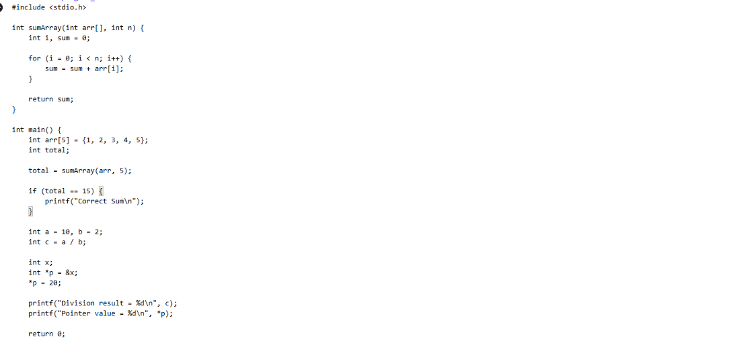

Code output:
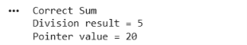

Q2.The following C program contains multiple lexical errors introduced intentionally. These errors occur due to invalid tokens, incorrect identifiers, malformed constants, and illegal symbols, which are typically detected during the lexical analysis phase of a compiler.Carefully examine the program and answer the questions given below.
#include <stdio.h>

int main() {
int 1num = 100;
float rate@ = 25.5;
char ch = 'abc';
int total = 50$20;
int num#1 = 30;
int %count = 40;

printf("Welcome to Compiler Design);

int x = 09;
int y = 0xZ12;
int z = 12.3.4;

char str1[] = "Hello;
char str2[] = "World";

int _valid = 10;
int invalid-id = 20;

float value = 5..6;
int data = 10@5;

char c = 'xy';
int 3value = 60;

printf("Value: %d\n", total);

return 0;
}
Tasks
(a) Error Identification
i) Identify all lexical errors in the program.
ii) List the line number and the invalid token.
(b) Error Classification
i) For each error, explain why it is considered a lexical error.
ii) Specify which rule of token formation is violated:
iii) Identifier rules
iv) Constant formation
v) String/character literal rules
vi) Operator/symbol rules
(c) Token Correction
i)Rewrite each invalid token into a valid token.
ii)Example: 2value → value2
(d) Compiler Behavior Analysis
i) Explain how a lexical analyzer (scanner) processes such errors.
ii)Discuss whether the compiler:
iii)Stops immediately
iv)Continues scanning using error recovery
(e) Advanced Thinking
i) Design a simple rule (or DFA idea) to detect invalid identifiers starting with digits.
ii) Suggest how error messages can be improved for beginners.

Answer:
Line | Error | Short Description
3 | 1num | Cannot start an identifier with a digit.
4 | rate@ | @ is not allowed in identifiers.
5 | 'abc' | Character must contain only one character.
6 | 50$20 | $ is an invalid symbol.
7 | num#1 | # is not allowed in identifiers.
8 | %count | % cannot start an identifier.
9 | "Welcome... | Missing closing quotation mark.
10 | 09 | Invalid octal number.
11 | 0xZ12 | Z is invalid in hexadecimal numbers.
12 | 12.3.4 | Two decimal points are invalid.
13 | "Hello | Missing closing quotation mark.
15 | invalid-id | - is not allowed in identifiers.
16 | 5..6 | Invalid floating-point number.
17 | 10@5 | @ is an invalid operator.
18 | 'xy' | Character literal has two characters.
19 | 3value | Cannot start an identifier with a digit.

Code:
#include <stdio.h>

int sumArray(int arr[], int n)
{
int i, sum = 0;

for (i = 0; i < n; i++)
{
sum = sum + arr[i];
}

return sum;
}

int main()
{
int arr[5] = {1, 2, 3, 4, 5};
int total;
int a = 10;
int b = 2;
int c;
int x;
int *p;

total = sumArray(arr, 5);

if (total == 15)
{
printf("Correct Sum\n");
}

c = a / b;
printf("Division result = %d\n", c);

p = &x;
*p = 20;
printf("Pointer value = %d\n", *p);

return 0;
}

Code input:
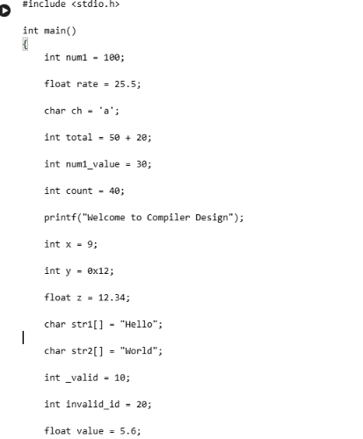
Output:
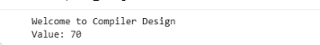

Q3. The following C program is designed to perform arithmetic operations, function calls, conditional checks, pointer usage, and looping. However, the program contains multiple errors distributed across different phases of a compiler, including:
- Lexical Errors
- Syntax Errors
- Semantic Errors
- Intermediate Code Generation Issues (logic/precedence)
- Code Optimization Issues (redundancy/inefficiency)
- Runtime / Target Code Errors
Carefully analyze the program and answer the questions below.

#include <stdio.h>

int divide(int a, int b) {
return a / b
}

int main() {
int #value = 20;
float num = 15.5
int result;

result = divide(10);

if(result = 5) {
printf("Result is 5\n")
}

int x = 10;
int y = 0;
int z = x / y;

int arr[4] = {1,2,3,4};
printf("%d\n", arr[4]);

int *ptr;
*ptr = 25;

int total;
total = x + y * result + 0;

while(x < 20) {
printf("%d\n", x);
}

return 0;
}
Do the following Tasks
(a) Identify Errors (Analysis Level)
- Identify all errors in the program.
- Mention line number + error description.

(b) Classify by Compiler Phase
Classify each error into:
- Lexical (invalid symbols like @num)
- Syntax (missing semicolon, brackets)
- Semantic (function argument mismatch)
- Intermediate Code Issues (wrong expression handling/precedence)
- Optimization Issues (redundant + 0)
- Runtime Errors (division by zero, invalid pointer access)

(c) Compilation vs Execution (Evaluation)
- Which errors are detected at compile time?
- Which errors appear only during execution?
- Explain why some errors prevent further compilation.

(d) Correct the Program (Application)
- Rewrite the fully corrected program.
- Ensure:
  - Proper syntax
  - Correct semantics
  - Safe execution

(e) Deep Analysis (Evaluation)
- Explain how incorrect pointer usage affects runtime.
- Analyze how array bounds violation impacts memory.
- Discuss how operator precedence errors affect intermediate code.

(f) Advanced Task (Create Level)
- Suggest 2 improvements in compiler design to:
  - Detect runtime errors earlier
  - Improve debugging messages
- Propose how optimization phase can remove redundant expressions.

Answer:
The given C program contains errors at different compiler phases. #value is an invalid identifier because # is not allowed in a variable name. The return a / b statement is missing a semicolon. The declaration float num = 15.5 also lacks a semicolon. The function divide() requires two arguments, but only one argument is passed. The condition if(result = 5) uses assignment instead of comparison; it should use ==. The statement printf("Result is 5\n") is missing a semicolon. The statement x / y causes division by zero because y is 0. The expression arr[4] accesses outside the array because valid indexes are 0 to 3. The pointer ptr is uninitialized before dereferencing, which can cause a runtime error. The expression x + y * result + 0 contains a redundant + 0, which should be removed during optimization. Finally, the while(x < 20) loop never increments x, causing an infinite loop.
Main Errors
Line | Error | Short Description
4 | return a / b | Missing ;
5 | } | Function syntax affected by previous error
9 | #value | Invalid identifier
10 | 15.5 | Missing ;
13 | divide(10) | Missing second argument
15 | result = 5 | Assignment used instead of comparison
16 | printf(...) | Missing ;
22 | x / y | Division by zero
25 | arr[4] | Array index out of bounds
28 | *ptr = 25 | Uninitialized pointer
31 | + 0 | Redundant expression; optimization needed
33 | while(x < 20) | x is never incremented, causing infinite loop

Code:
#include <stdio.h>

int main()
{
int num1 = 100;

float rate = 25.5;

char ch = 'a';

int total = 50 + 20;

int num1_value = 30;

int count = 40;

printf("Welcome to Compiler Design");

int x = 9;

int y = 0x12;

float z = 12.34;

char str1[] = "Hello";

char str2[] = "World";

int _valid = 10;

int invalid_id = 20;

float value = 5.6;

int data = 10 * 5;

char c = 'x';

int value3 = 60;

printf("\nValue: %d\n", total);

return 0;
}

Code input:

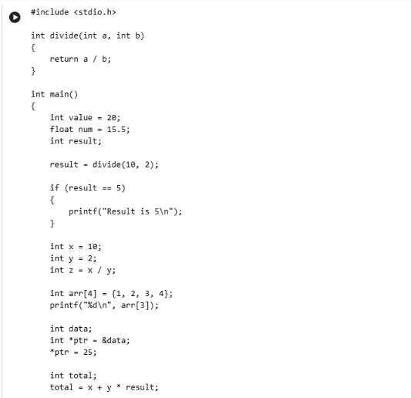

Output:
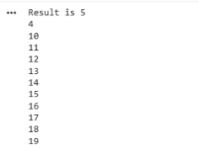

RUBRICS FOR CALCULATION:

Criteria | Weightage | Level 4 (Exemplary) | Level 3 (Proficient) | Level 2 (Developing) | Level 1 (Beginning)
Error Identification | 20% | Accurately identifies all errors with clear understanding of issues | Identifies most errors with minor omissions | Identifies limited errors; some are missed | Fails to identify key errors
Root Cause Analysis | 30% | Clearly explains underlying causes with strong technical reasoning | Explains causes with moderate clarity | Partial explanation; weak reasoning | Unable to identify causes of errors
Correction & Justification | 25% | Provides correct solutions with strong justification and logic | Provides correct corrections with some justification | Corrections are partially correct or weakly justified | Incorrect or no corrections provided
Application of Concepts | 15% | Effectively applies relevant concepts to analyze and resolve errors | Applies concepts with minor errors | Limited application; requires guidance | Unable to apply concepts
Clarity & Presentation | 10% | Presents analysis clearly, logically, and systematically | Generally clear with minor issues | Lacks clarity or proper structure | Poor presentation and difficult to understand

